Deep learning ICP 2:

Kamal Tej Veerapaneni

1. Epoch:10 batchsize:128

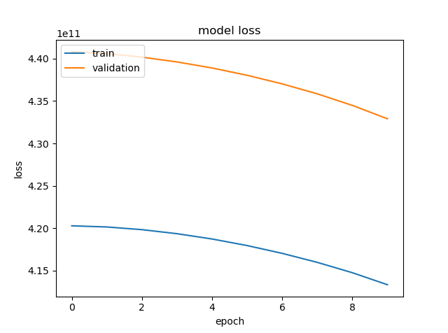

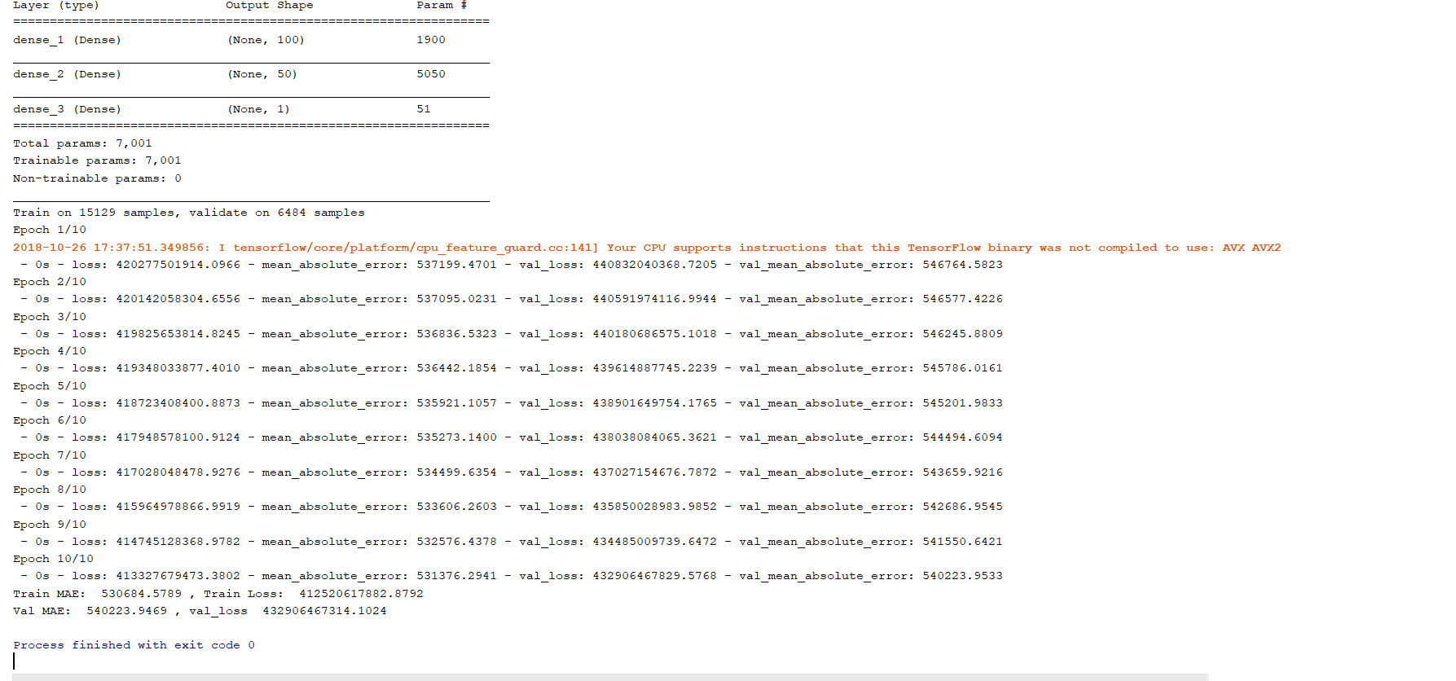

=====================================================================================

After successfully calculating loss now we change various parameters:

2-a)

Epoch=200 batch size=128

Dense(80) Activation:sigmoid Optimizer:Adam()

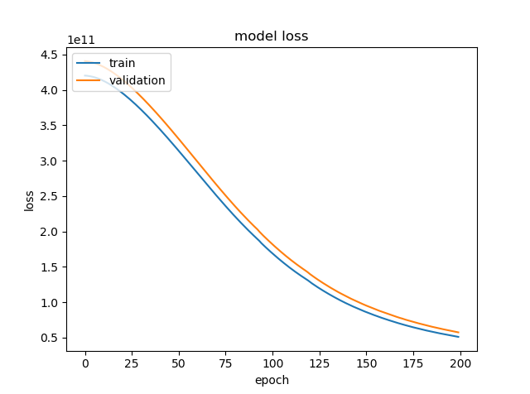

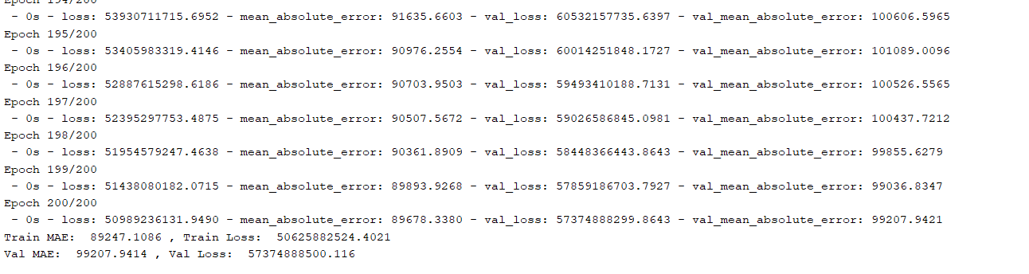

Epoch:30 batch:128



2-b)

Epoch=200 batch size=128

Dense(80) Activation:sigmoid Optimizer:RMSprop()

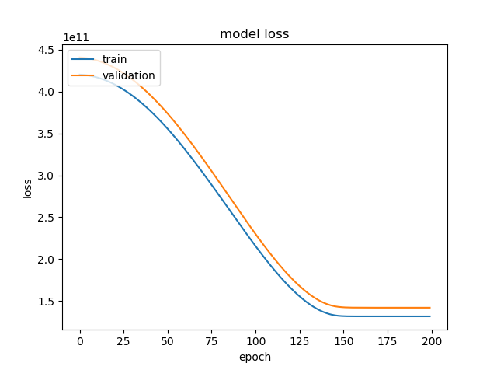

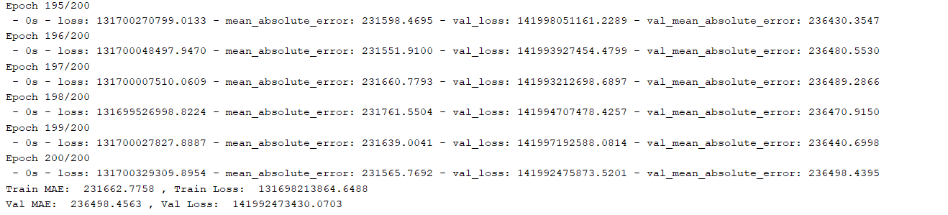

Epoch:30 batch size:12

Dense(80) Activation:sigmoid Optimizer:Adam()

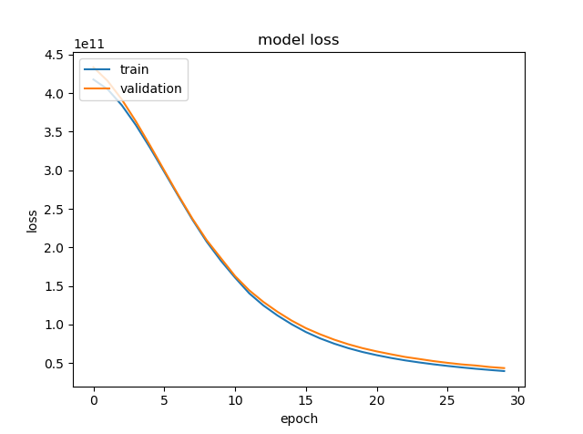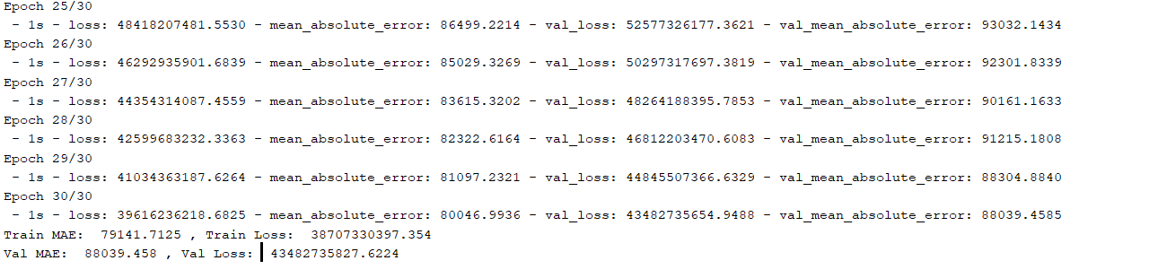

Epoch:30 batch size:12

Dense(80) Activation:sigmoid Optimizer:RMS prop()

